Candidate name: | Chan Zun Mun Terence

Question 1
Evidence 1
The program code to perform Task 1.1
###Task 1.1##############
def readFile():
###Reading File##################
dataFile = open("DATA.TXT", "r")
data = dataFile.read()
dataFile.close()

values = data.split("\n")
processedValues = []
for i in range(len(values)):
###Processing each line of data#############
valList = values[i].split("V")
if len(valList) == 4: #In appropriate format
###Formatting Date###
days = int(valList[0][1:]) + 9
months = days // 31 + 9
days = days % 31
years = months // 12 + 1965
months = months %12
DATE = f"{days:02}{months:02}{years:04}"
###Fromatting Other Values###
VALUE1 = float(valList[1][1:])
VALUE2 = float(valList[2][1:])
VALUE3 = float(valList[3][1:])
#print(DATE, VALUE1, VALUE2, VALUE3)
processedValues.append((DATE, VALUE1, VALUE2, VALUE3))
return processedValues
values = readFile()

Evidence 2
insertion_sort_means program code
###Task 1.2###################
def compare_means(val1, val2):
mean1 = (val1[1] + val1[2] + val1[3])/3
mean2 = (val2[1] + val2[2] + val2[3])/3
#First few elements should be LARGER than next few elements
return mean1 > mean2 #Descending

def insertion_sort_means(arr):
l = 0
r = len(arr)-1
for i in range(1, r+1):
#print(i)
key = arr[i]
j = i - 1 #Index of element to be shifted
while j > 0 and not compare_means(arr[j],key):#arr[j] < key:
arr[j+1] = arr[j]
j -= 1
arr[j+1] = key #Fill in the empty space created
#Once done sorting
for i in range(len(arr))
print(arr[i])

insertion_sort_means(values)

Question 2
Evidence 3

HashKey program code
###Task 2.1######################
def HashKey(ThisCountry):
ThisCountry = str(ThisCountry)
total = 0
for char in ThisCountry:
total += ord(char)
remainder = total % 373
key = remainder + 1
return key

#Test for Task 2.1
print(HashKey("India"))
Evidence 4

CreateCountry program code
###Task 2.2#################
def CreateCountry():
###Open Country File####
countryFile = open("COUNTRIES.TXT")
line = countryFile.readline()
firstCountry = line.split()
countryFile.close()

###Data Processing######
name = firstCountry[0]
population = firstCountry[1]
address = HashKey(name)
#print(name, data, address) #Debugging
###NEWFILE###############
newFile = open("NEWFILE.TXT", "w+") #Write mode
data = newFile.read().split()
if len(data) < 10: #First Writing / Insufficient Length
for i in range(250):
data.append(" ")
data[address] = line
###Overwriting to new file
newFile.seek(0)
for i in range(len(data)):
newFile.write(data[i]+"\n")
newFile.close()

CreateCountry()
Evidence 5

LookUpCountry program code

###Task 2.3#################
def LookUpCountry():
###User Inputs the Country Name######
name = input("Enter the country name: ").strip()#Remove trailing whitespaces
###Address Hashed from country Name#######
address = HashKey(name)
print(address)
###Country and Population located in NEWFILE###############
newFile = open("NEWFILE.TXT", "r")
data = newFile.readlines()
newFile.close()
###The address, the country name and population are output#####
countryData = data[address][:-1].split() #Remove newline character
name = countryData[0]
population = countryData[1]
print("Information about country:")
print(f"Address: {address}")
print(f"Name: {name}")
print(f"Population: {population}")
LookUpCountry()
Evidence 6

Screenshot
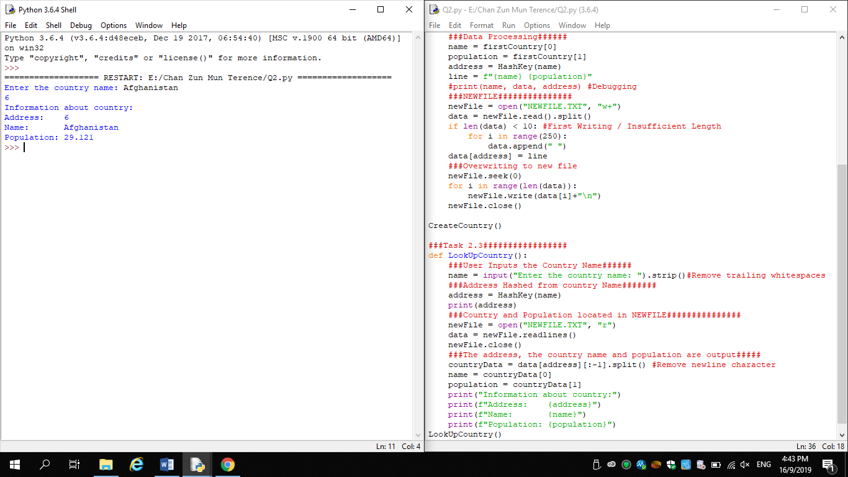
Evidence 7

Amended CreateCountry program code
###Task 2.4#################
def CreateCountry():
###Open Country File####
countryFile = open("COUNTRIES.TXT")
countries = countryFile.read().split("\n")
countryFile.close()
###Data Processing######
data = [""] * len(countries)
for i in range(len(countries)):
line = countries[i]
country = line.split()
if len(country) > 0: # If there is valid data
name = country[0]
population = country[1]
hashkey = HashKey(name)
#####Collision#####################################################
address = hashkey
loop = 0 #Number of loops around the dataset
while (address < 0 or address >= len(data)) or \
(data[address] != "" and \
loop < 1):
#print(address)
address += 1 #Move on to next address
if (address < 0 or address >= len(data)):
address = 0
if address == hashkey:
loop += 1
##In case size of data is too big###########
if loop >= 1:
Exception("Error")
#######################################################################
data[address] = line

###NEWFILE###############
newFile = open("NEWFILE.TXT", "w+") #Write mode
###Overwriting to new file
newFile.seek(0)
for i in range(len(data)):
newFile.write(data[i]+"\n")
newFile.close()

CreateCountry()
Evidence 8

Amended LookUpCountry program code
###Task 2.5#################
def LookUpCountry():
###User Inputs the Country Name######
name = input("Enter the country name: ").strip()#Remove trailing whitespaces
###Address Hashed from country Name#######
hashkey = HashKey(name)
###Country and Population located in NEWFILE###############
newFile = open("NEWFILE.TXT", "r")
data = newFile.readlines()
newFile.close()
###The address, the country name and population are output#####

#####Collision#####################################################
address = hashkey
loop = 0 #Number of loops around the dataset
while (address < 0 or address >= len(data)) or \
(data[address] != "" and \
loop < 1 and \
name+" " not in data[address] ):
address += 1 #Move on to next address
if (address < 0 or address >= len(data)):
address = 0
if address == hashkey:
loop += 1
##In case size of data is too big###########
if loop >= 2 :
print("The country cannot be found")
return
#######################################################################
countryData = data[address][:-1].split() #Remove newline character
if len(countryData) >= 2: #If there is sufficient data
population = countryData[-1]
name = data[address][:-1-len(population)] #Extract from data
print("Information about country:")
print(f"Address: {address}")
print(f"Name: {name}")
print(f"Population: {population}")
LookUpCountry()
Evidence 9

Two screenshots
